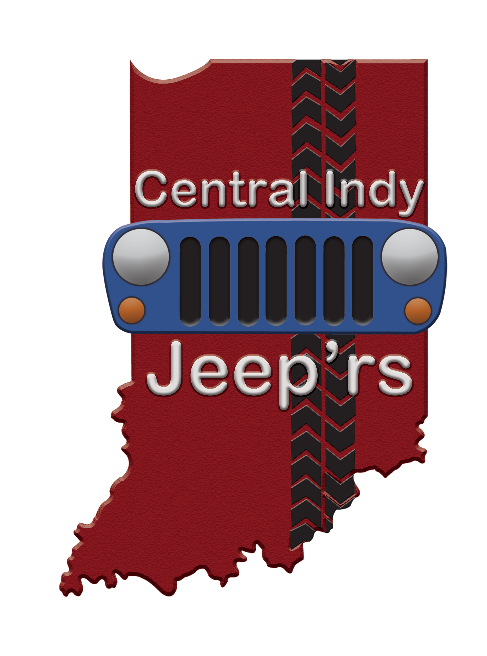
CENTRAL INDY JEEP’RS CLUB BYLAWS
Rev 4-22-20

1) MISSION STATEMENT
To promote a safe, fun and family friendly group of Jeepers for on and off-road events, while also being involved and giving back to the local community! We are funded by member donations, fund raising events and contributions. We are governed by a Board of Directors, which serves without compensation, and a staff of Directors. We offer everything from family-oriented trail rides to show and shine type of events. We have something for everyone and are involved in the community by giving back. Be it our time, fundraising, or other avenues we will always make a positive light of the club and family we call Central Indy JEEP'rs! If this is something you are interested in being part of please click on the Facebook link in the above header of this site or email: admin@centralindyjeeprs.com
2) MEMBERSHIP
Requirements for current or prospective members include the following:
a) Be the owner of a jeep or other off-road capable vehicle. This rule can be bent at the discretion of Central Indy Jeep'rs officers if an individual is deemed to be a potential asset to the club. No official vote is required. This is only intended to be a general guideline
b) Membership includes all members of a particular household.
c) Any Central Indy Jeep'rs member whom operates a motor vehicle at a club function must possess a valid driver's license and carry insurance on said vehicle which satisfies the minimum legal requirements in the state for which the vehicle is registered in.
d) All members will have voting privileges within the club. Each membership is granted one vote on a per family basis.
e) Each participant of any Central Indy Jeep’rs event must sign a Central Indy Jeep'rs liability waiver.
f) Central Indy Jeep'rs will not be held responsible for injuries to a member, guest, pet and/or prospective member. Central Indy Jeep'rs will not be held responsible for damage or loss to any vehicle or personal property at any organized Central Indy Jeep'rs event, meeting, or scheduled trail ride. Participation in any Central Indy Jeep'rs event is voluntary and is solely at the risk of those who chose to participate.
3) DUES
a) At the time of the writing of this document there are no membership dues. Central Indy Jeep'rs reserves the right to impose membership dues at any time as long as it is approved by a majority vote of ALL Central Indy Jeep'rs officers. Financing of this group is done by member donations and outside donations or contributions.

4) CONDUCT AND ACTIVITY RULES
a) All club members must conduct themselves in a manner which is consistent with club standards and ideals. Any member who does not conduct themselves appropriately may be subject to disciplinary action up to and including dismissal from the club. Any member should bring his / her complaint or issue to the Chief Security Officer. The Chief Security Officer will then present the complaint to the President. The President will present the issue to a vote of the board members. If the board members believe the complaint has merit via method of vote, majority rule, the Chief Security Officer will issue a warning to the offending member. Central Indy Jeep'rs adheres to a 3 strikes and out policy in which ANY member will be given two warnings. The first time the member will be given a warning via either verbally or electronic communications. The second time the member will be warned and will then be muted to any social media forums related to the group for a period of one month. Upon the third offense the member will be permanently removed from the organization.
b) Members will be held accountable for the actions for their guests.
c) Any member whom possesses a firearm during any club activity does so at their own risk and liability. Any member who chooses to carry a weapon should do so safely and discreetly. The member must also follow all Local, State and Federal laws regarding the carry and use of such weapon.
d) Any attempt to dismantle the group or undermine any club function, or any attempt to cause damage to the reputation or integrity of the group or any member of the administrative group is subject to immediate dismissal from the group and will be banned from the group permanently. If it is determined that it its necessary, the President or the first responding officer will immediately dismiss all involved members.

e) Effective as of May 1st 2020 there will be no posting of any events unless it is done by the president or the Chief Event Coordinator.

f) Any interpersonal issues related to anyone in the Admin team will be directed to the President and handled in as timely of a fashion as possible. If necessary, the issue will go directly to the board and they will have a decision as to how to handle this situation. Should the board decide to remove a particular individual, Slanderous activity will not be tolerated and litigation.

g) A blatant disregard of the wishes of a higher-ranking Officer is grounds for immediate removal from the group upon approval of the board.

h) CIJ is a business under state guidelines and will operate as such. Anyone exhibiting less than professional behavior is subject to be reviewed by the board and actions will be taken. The decision of the board is final no matter what the decision may be.
5) TRAIL RIDE RULES
a) All members are responsible for their own safety on trial. Central Indy Jeep'rs is not liable for any accident or injury.
b) Any Drivers on trail rides or road rallies must have a Waiver of Liability on file prior to participating in a Central Indy Jeep'rs event
c) No vehicle Trail Blazing.
d) Pets must be controlled by owner.
e) Do not litter! If you haul it in, Haul it out!

6) ALCOHOL, DRUGS, AND OTHER INTOXICATING SUBSTANCES
a) Operating a vehicle while consuming or under the influence of alcohol, drugs or other intoxicating substances will not be permitted on trial rides or any CIJ club sponsored event. In addition, drivers are to obey all posted park-specific and state/federal specific rules and laws regarding alcohol/drug consumption.
b) Open alcohol containers are prohibited in a moving vehicle at an aforementioned event
c) Drivers are fully responsible for the actions of their passengers

7) VEHICLE EQUIPMENT
a) Vehicles must be maintained in a safe manner, have proper license plates if applicable, and be in compliance with all federal, state, and local laws. Each driver must have a valid driver’s license and have a waiver on file with Central Indy Jeep’rs.
b) Fire Extinguishers, First Aid Kit, and a proper tow strap are RECOMMENDED with every vehicle participating in a Central Indy Jeep'rs event.
c) A roll cage or factory unitized roll protection structure as well as a safety belt for every passenger is required on every vehicle. No Exceptions.
d) A spare tire within two inch of the diameter of the vehicle tires is mandatory for every vehicle on a trail ride.
e) Front and rear tow points and a CB radio are HIGHLY RECOMMENDED for all vehicles on a trail ride.
8) OFFICERS AND DUTIES:
In the Spirit of a family club, couples shall be allowed to run for a single office and share the responsibilities entailed. In these instances, the office retains a single vote and voice within the board.
All officers must attend at least 75% of all scheduled meetings. In the event an elected officer fails to meet his or her attendance responsibility, the President will address with a direct discussion of the issue with the officer. If the attendance requirement is not immediately corrected the President will call for the Board of Directors to appoint a replacement for the officer by majority vote. The appointed member will serve the balance of the term until the next scheduled elections.

President and Chief Executive Officer - Marty Trimnell
• Length of term – Lifetime unless it is determined the acting president is physically or mentally incapable of performing duties of the office held. If it is determined by a 75% vote of all officers the president is no longer capable of serving, the Chief of Operations will then take over all responsibilities of the president until a new president can be elected. This Presidential election must be a majority rule of All Officers of the group and must take place within 90 days of the dismissal of the acting president.
• Exercise general supervision of the club, club affairs, and represent the club in any meetings outside the organization.
• Conduct general membership and board meetings (as needed)
• Manage the club calendar of events and assure delegation of assignments to event coordinators
• Assist in planning and coordination of any and all group events.

Chief of Operations – Kimberly Stevenson
• Length of term – Lifetime unless it is determined the acting Chief of Operations is physically or mentally incapable of performing duties of the office held. If it is determined by a 75% vote of all officers the Chief of Operations is no longer capable of serving, At this point the President, Chief Financial Officer, and Chief Administrative Officer must appoint a new Chief of Operations.
• Record minutes of all club meetings, post in all social media forums for review of all club members.
• Maintain a copy of all club membership paperwork( If Necessary ), rosters, and waiver documents.
• Provide a copy of all documents to the club President as a backup
• Assist in administration/moderation of Central Indy Jeep'rs social media outlets.

Chief Financial Officer – Tracie Camden
• Length of term – Lifetime unless it is determined the acting Chief Financial Officer is physically or mentally incapable of performing duties of the office held. If it is determined by a 75% vote of all officers the Chief of Operations is no longer capable of serving, At this point the President, Chief of Operations, and Chief Administrative Officer must appoint a new Chief Financial Officer.
• Maintain all club finances.
• Maintains all club accounting and financial records.
• Verify all club finances are being handed in a responsible and effective manner
• Assist in administration/moderation of Central Indy Jeep’rs social media outlets.

Chief Administrative Officer – Brent Humphress
• Length of term – Lifetime unless it is determined the acting Chief Administrative Officer is physically or mentally incapable of performing duties of the office held. If it is determined by a 75% vote of the President Chief Financial Officer and Chief of Operations the Chief Administrative Officer is no longer capable of serving, at this point the President, Chief Financial Officer, and Chief of Operations must appoint a new Chief Administrative Officer.
• Performs any duties as directed by the President, Chief Financial Officer, or the Chief of Operations including such things as assisting with planning of group events, Promoting the group and its functions and any other duties assigned.
Chief Event Coordinator – Amber Biddle
• Length of term – Lifetime unless it is determined the acting Chief Event Coordinator is physically or mentally incapable of performing duties of the office held. If it is determined by a 75% vote of all officers the Chief Event Coordinator is no longer capable of serving, at this point the President, Chief of Operations, and Chief Administrative Officer must appoint a new Chief Event Coordinator.
• Primarily responsible for all event function planning.
• In charge of leading CIJ Event Coordination Committee
• Assist in administration/moderation of Central Indy Jeep’rs social media outlets
Chief Security Officer – David Schaefer
• Length of term – Lifetime unless it is determined the acting Chief Security Officer is physically or mentally incapable of performing duties of the office held. If it is determined by a 75% vote of all officers the Chief Security Officer is no longer capable of serving or is not performing the position in a professional, safe, or secure manner, at this point the President, Chief Financial Officer, and Chief of Operations must appoint a new Chief Security Officer.
• Closely monitors and handles with the assistance of the President, Chief Financial Officer, and Chief of Operations any conflicts or issue that may arise within the group.

Board Members – Melinda Marie Nevins | Brian Richard | John Fix | Kimberly Mimi Bogemann | Stacey Stevens Morton
• Length of term – 3 years unless it is determined any acting board member is physically or mentally incapable of performing duties of the office held. If it is determined by a 100% vote of the President, the Chief Financial Officer, and the Chief of Operations that the board member is no longer performing his / her duties, at this point the President and Chief Financial Officer, and Chief of Operations must appoint a new board member.
• Board members will vote on any and all club financial expenditures which are of a total of $200.00 or more. Majority rule.
• Board members will vote on any proposals of changes to the by-laws of the group or the fashion in which it functions. This vote will run for 24 hours and in the event of a no vote situation the President, Chief Administrative Officer, Chief of Operations, Chief Event Coordinator, and Chief Financial Officer will make the decision. Majority Rule.

Board Liaison - Brian Richard - Length of term – 3 years unless it is determined any acting board member is physically or mentally incapable of performing duties of the office held. If it is determined by a 100% vote of the President, the Chief Financial Officer, and the Chief of Operations that the board member is no longer performing his / her duties, at this point the President and Chief Financial Officer, and Chief of Operations must appoint a new board member.
• Acts as a representative of the Admin crew to and for the board of directors and vice versa.
• Remains involved in all admin conversations.
• Reports any concerning activities in the admin group to the board of directors, and delivers any vote results to the entire group.
• Acts as a representative of the Board of Directors

RESERVE BOARD MEMBER – Brent Humphress
• Acts as a backup board member and all duties and responsibilities of regular board members apply to this position.

These positions will be posted on a monthly basis on the Groups social media outlet. Also each member of each committee and their role will be posted as well.
9) ELECTIONS:
a) Election of board members will be done every 3 years beginning 1-12-20. This will be done in the month of January via the Central Indy Jeep'rs social media Poll feature or via a special virtual election. Electronic base poll Elections will last approximately 48 hours.
b) Only members in good standing with the club for a period of one full year may be considered for an officer position in the club. For consideration of the offices of President, Chief of Operations and Chief Financial Officer the member must be a member in good standing for a period of not less than two (2) full years.

c) Members whose leadership positions in other associations which could potentially be construed as being in conflict of interests with Central Indy Jeep'rs, shall not be eligible for elected office unless; Appointed by the Board of Directors to fill an unscheduled vacancy for an officer role, pro-tempore; Over one calendar year has passed since a leadership position in other organization was held, and no direct conflict of interests are apparent.

d) Every Central Indy Jeep'rs member in good standing with the club is allowed one vote for each office position. Duplicate votes from other family members are not allowed.
e) New officers elected will assume the role of their perspective position at the beginning of the following week after the election to allow sufficient time for position turn-over.

10) BYLAW CHANGES
a) Any changes of the bylaws must be initiated by either the Chief of Operations, President, or Chief Financial Officer then approved by the remainder of those three individuals. Once complete this must meet board approval via special meeting or electronic vote. Majority rule.

11) CLUB FUNDS
a) All club funding is 100 percent donation driven. At the time of the writing of this document there are no club dues.

b) If it’s necessary for the survival of the group financially then group dues may be imposed and may amount to no more than $50 per year per family.

c) Any spending of group funds below $200.00 must be approved by the President or Chief Financial Officer.

12) MEETINGS

a) Business meetings will be held on a quarterly basis. Beginning in January of 2020 they may be held on any day of the month of January, April, July, or October. These meetings should consist of a bare minimum the President, Chief Financial Officer, Chief of Operations, and all board members.

b) All minutes from these meetings must be public information and must be available upon request.

c) Minutes information will be displayed to members in a brief posting to the group’s social media outlet. This should be performed by the Chief of Operations but may also be performed by the President or the Chief Financial Officer.

d) A brief monthly financial summary will be posted to the group in regards to the amount of funds outgoing and the amount incoming. This will primarily be a function of the Chief Financial Officer or the President as needed.

